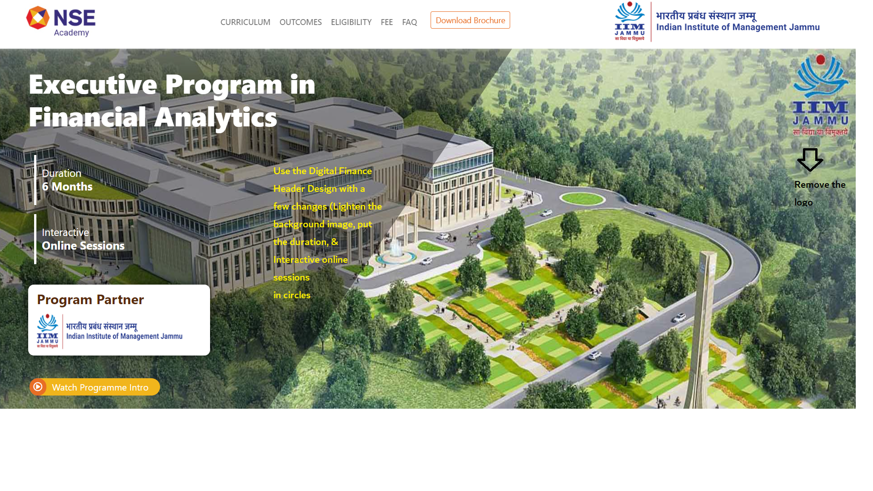

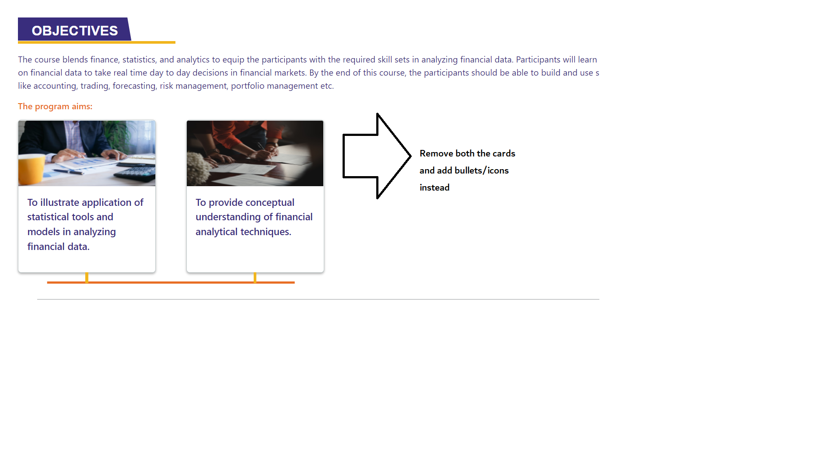

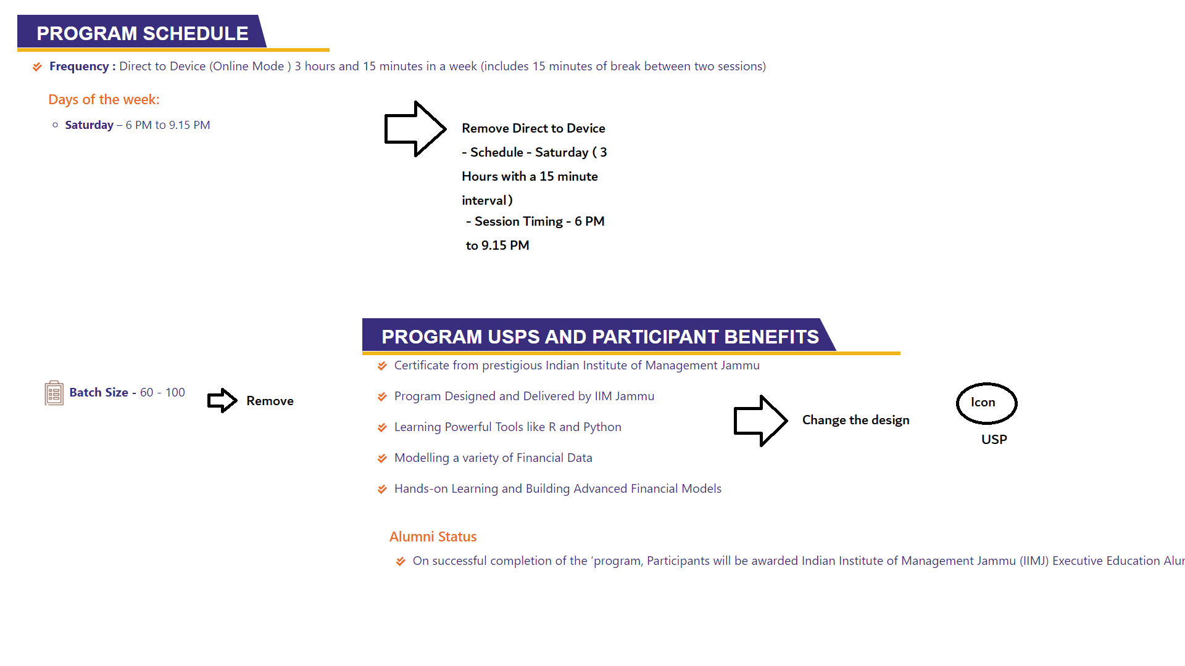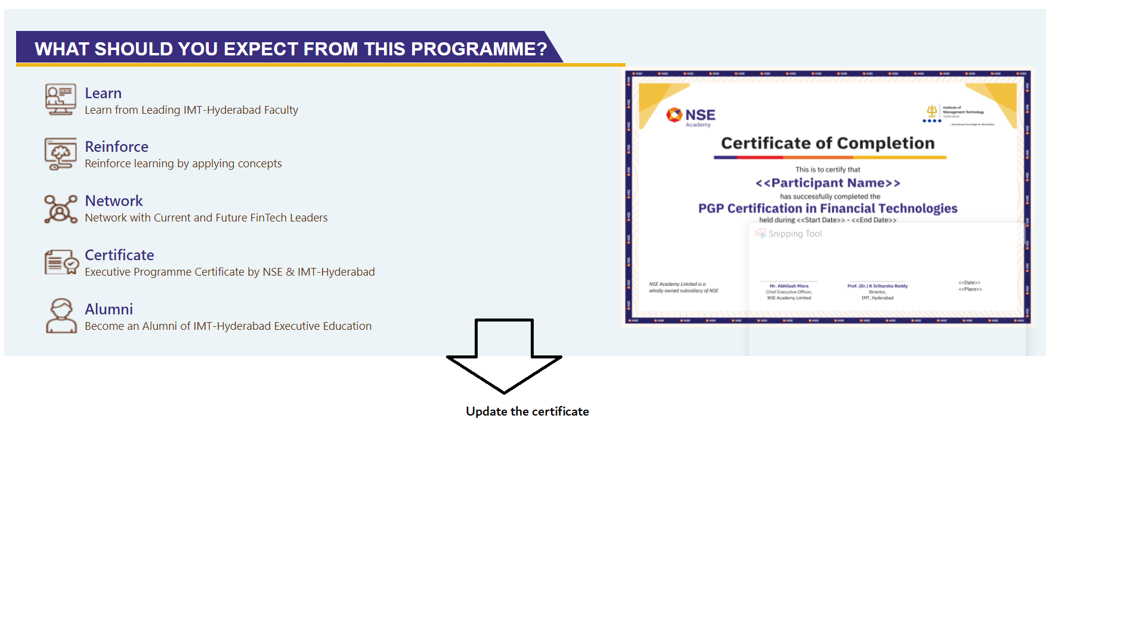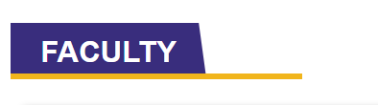Change this to “Program Directors”

Pankaj Agarwal card should come first

Add “Special Corporate Pricing” link

Add EMI option - Zero Cost

| Program Fees - 90,000/- + 18% GST | 106200 |
| --- | --- |
|  |  |
| 6 Months | 17700 |
| 9 Months | 11800 |
| 12 Months | 8850 |

Make terms & conditions collapsable